Regarding the latest build

1. On Homepage, if we scroll to the extreme bottom, then the right panel cuts the footer

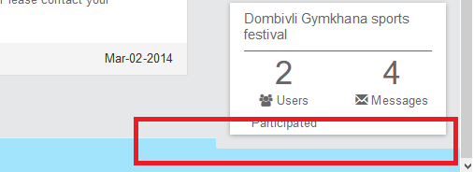

[Monil Gangar]: Fix this issue

1. Is there any logic in which the elements are displayed on the time-line. In which cases would we have 2 card displayed one below the other as in the current home page.

Need to avoid scenario when(if) all cards start displaying themselves on either side. That will severely break the look of the UI.

[Monil Gangar]: There is no logic behind showing cards on any side. I have shown it for display purpose only. We can show cards alternately. i.e. one card on right side and one card on left side.

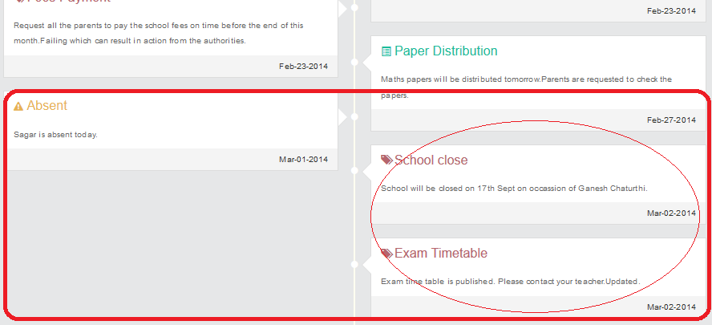

1. We missed out on these ones in previous build
2. The text "Users Participated" in the right column flows on to the next line. We can have "2 participants" instead of "2 users participated" and see if it fits in the same line.

[Monil Gangar]: Done

And logos here also need to be the colorful

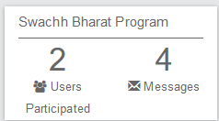

[Monil Gangar]: Done. Also changed the color.

1. We can try few other colors on the header, it is giving a facebook-ish look

[Monil Gangar]: Please suggest better color. My color selection is bit different than yours. It is better if you suggest better color in RGB or Hex format I will apply it on UI. You can try changing the color in UI only. Search for “.skin-black .navbar” css class in skin.css file. Then you can play with different colors by changing background color property.

1. Hide/remove this separation line



[Monil Gangar]: Done

1. Now that the messages section is smaller, the "Send" button looks sore

Can we make it a part of the text box itself? Show only if something is written in the text box. It should stay hidden by default

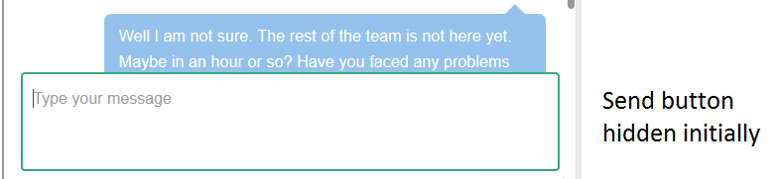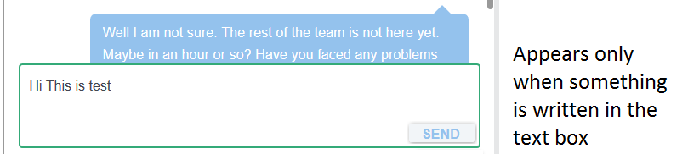

[Monil Gangar]: We should keep send button outside the box only. There are 2 main reasons behind that. 1. Button may get overlap with the underline text message.

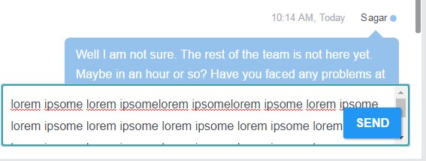

2. We need to add Upload document button also which we can align it with current send button position.

Keep the send button as is. I have changed the CSS of the button. Now it will look good.

1. We will need some divider between messages navigation panel and conversation box.

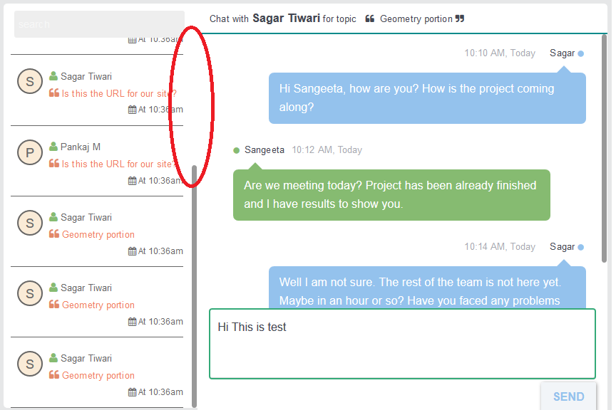

When the number of messages increase, the scroll bar in the messages navigation panel will start becoming smaller and there won’t be anything that separates the actual conversation from the messages navigation column *(need your input here)*

[Monil Gangar]: Yes we need some border there. Separated the two sections by adding border.

1. Alerts
2. Similar issue as that of the home page, Are the cards displayed using some logic?

[Monil Gangar]: There is no logic behind showing cards on any side. I have shown it for display purpose only. We can show cards alternately. i.e. one card on right side and one card on left side.

In this case we can see the space separating the bullets is diminishing

[Monil Gangar]: It is looking fine at my end. Can you please check this once again?

Will those bullets overlap at one point if similar sized cards are being displayed continuously?

[Monil Gangar]: Yes. Bullet may overlap at some point. We can fix this issue by giving minimum height to the timeline card. Please look new UI for this. I have made changes in the UI. Now it is looking similar to what you have shared as an example link.

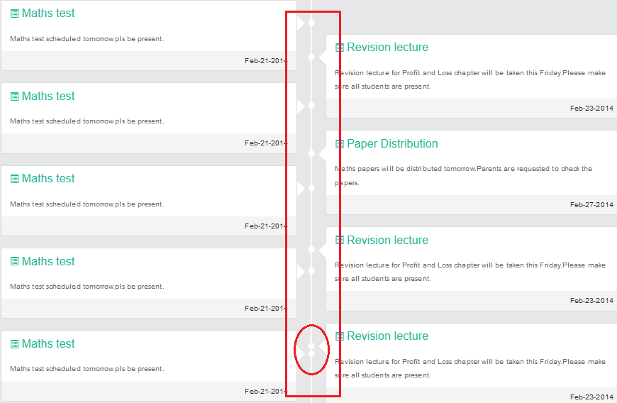

1. One common point that applies to the timeline feature

The point where the card connects to the central line is a simple bullet. We have seen some examples where the bullet can be modified.

We will require it to be that way on the main timeline of the home page, where each card is identified using a bullet icon (we already have icons for each section)

[Monil Gangar]: We can change the bullet on Home page add bullet icon as well. Which icon you are suggesting for each section? The new icon8 icons or old icons?

[Monil Gangar]: Thanks for this examples. We can refer to the first example and change our UI accordingly. This will also avoid our overlapping issue as well.

Few examples:

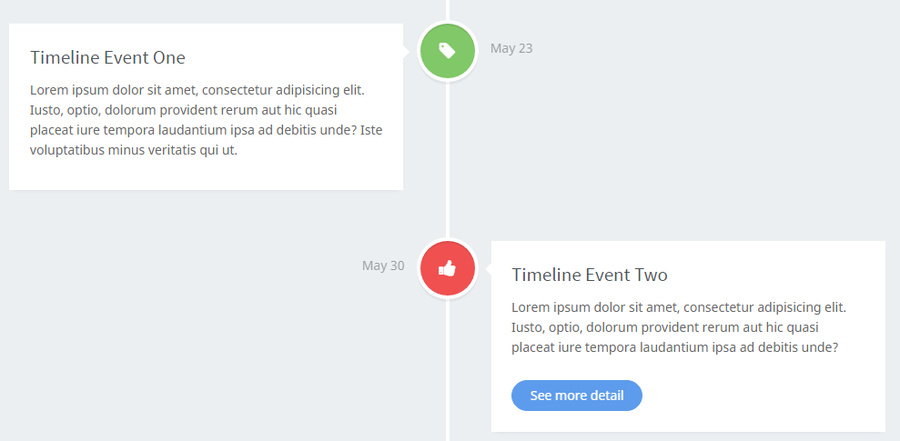

<http://coderthemes.com/ubold_1.5/light/extra-timeline.html>

[Monil Gangar]: Referred this above URL and changed the UI accordingly.

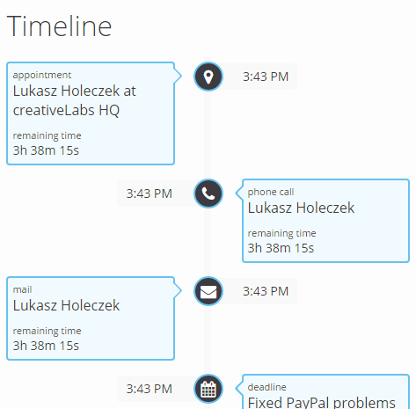

<http://wrapbootstrap.com/preview/WB0JLR295>

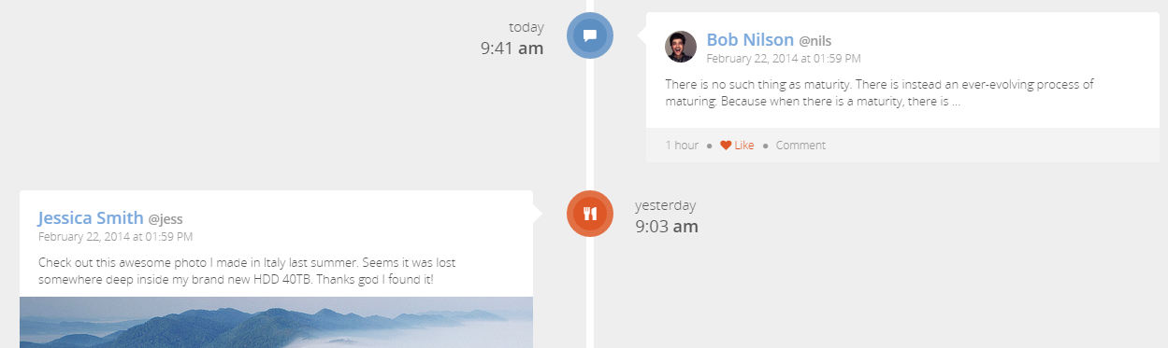

<http://wrapbootstrap.com/preview/WB0J6BJ85>

<http://wrapbootstrap.com/preview/WB04HF123>

<http://wrapbootstrap.com/preview/WB00XNXM0>

<http://wrapbootstrap.com/preview/WB0CX3745>